### Literature Review on News Providers







|  |  |
| --- | --- |
| **Project Name:** | N - Trading |
| **Name:** | Leung Kai Yiu |
| **Admin ID:** | 1001423A |

**Content Page**

|  |  |
| --- | --- |
| 1. **Purpose and Background** | **1** |
| 1. **Constraints & Limitation** | **1** |
| 1. **Reuters**   **3.1 News Analytics Tool (**Thomson Reuters News Analytics**)** | **1 - 2** |
| 1. **Wall Street Journal**   **4.1 News Analytics Tool (**Dow Jones News Analytics**)** | **2** |
| 1. **Bloomberg**   **5.1 News Analytics Tool (**Event-Driven Trading Feed**)** | **3** |
| 1. **Overall Comparison**   **6.1 News Wire**  **6.2 News Journalists**  **6.3 Market Data & Analysis Industry**  **6.4 Average Scoring from online reputable Review websites**  **6.5 Unique Visitors per month** | **4 - 5** |
| 1. **User Reviews**   **7.1 Reuters**  **7.2 Wall Street Journal**  **7.3 Bloomberg** | **5 - 6** |
| 1. **Meeting our criteria**   **8.1 Clear and concise headlines**  **8.2 Summary in a single paragraph** | **7 - 8** |
| 1. **Conclusion** | **8 - 9** |
| 1. **Appendix** | **i - viii** |
| 1. **References** | **viiii** |

1. **Purpose and Background**

This report presents the findings of News Providers on the net. The purpose of the Report is to outline the suitability of the News Providers for our News Analytics Program. The Report will also mention the existing News Analytics Tool launched by the News Providers in order to find out elements needed for News Analytics Tool.

1. **Constraints & Limitation**

Some of constraints we faced are as followed:

|  |  |
| --- | --- |
| **Constraints** | **Description** |
| Technical | With limited technical skills we are equipped with, we are constraints into small scopes. Thus, we must ensure that out scopes are manageable by finding News Provider’s site that are easy for us execute our algorithm. |
| Cost | Without any funding, there is no chance for us to subscribe Professional Services provided by the News Providers. This in turn, may cause us to face latency in news feed. |

1. **Reuters**

Reuters is one of the most professional informational companies in the world and they offer news as a free service to everyone. The site brings you the latest news from around the world, covering breaking news in business, politics, entertainment, technology, and more in video and pictures. ("Top 7 News Sources," n.d)

**3.1 News Analytics Tool**

Thomson Reuters News Analytics (TRNA) for Internet News and Social Media is a powerful tool that automatically analyzes millions of public and premium sources of internet content. With its ability to track news sentiment over time, TRNA provides a more comprehensive understanding of a company’s news coverage for investors and turns the mass of data into actionable analytics that can be used to power quantitative strategies across markets, asset classes, and all trading frequencies, support human decision making, and assist with risk management and asset allocation decisions. For instance, providing improved buy/hold/sell signals. (“Thomson Reuters News Analytics,” 2010)

The TRNA engine is based on tried and tested technology that is widely deployed by trading firms to analyze Reuters News and a host of other professional news wire services. TRNA for Internet News and Social Media leverages this core technology to analyze content sourced in collaboration with Moreover Technologies, which aggregates content from more than four million social media channels and 50,000 Internet news sites. This content is then analyzed in real-time by the TRNA engine, generating an output of quantifiable data points across a number of dimensions such as sentiment, relevance, and novelty. These and many other metrics can help analysts understand with greater context, what is being said and how it is being said across a number of media channels for a more complete picture. (“Thomson Reuters News Analytics.” 2012)

Refer to Appendix A for TRNA’s Text Scoring and Metadata.

1. **Wall Street Journal (**Subset of Dow Jones**)**

Dow Jones & Company is a global provider of news and business information and a developer of technology to deliver content to consumers and organizations across multiple platforms. Its premier brands include The Wall Street Journal, Dow Jones Newswires, Factiva, Barron's, MarketWatch, SmartMoney and All Things D. Its information services combine technology with news and data to support business decision making. The company pioneered the first successful paid online news site and its industry leading innovation enables it to serve customers wherever they may be, via the Web, mobile devices and tablets. (“Press Release”, 2012)

**4.1 News Analytics Tool**

Dow Jones, a leader in news analytics and machine-readable news, launched the first machine-readable news feed for institutional traders, the Elementized News Feed, in 2007 and the first trading tool to convert news content into actionable data for trading models, Lexicon, in 2010.

On Feb. 14, 2012, Dow Jones introduced Dow Jones News Analytics which combines Dow Jones' world-class business news content with key technology partners including Alexandria, Digital Trowel, RavenPack and SemLab. This tool adds depth to investors’ trading models as it analyzes real-time and historical news and data for sentiment, relevance, volume, novelty and other market signals via a range of technology options. (“Dow Jones Introduces News Analytics,” 2012)

Some of the News Analytics’ features are as follow:

* Choose the right solution from a network of thoroughly vetted technology partners
* Sentiment data derived from Dow Jones global, multi-asset news
* Access to a deep archive of consistently tagged news and data for use in identifying market signals
* A range of deployment options, from data feeds to hosted solutions to fully customized integrations

1. **Bloomberg**

One of the premier sites for business and financial market news, Bloomberg is a news source about everything that is in any way related to the financial markets. ("Top 7 News Sources," n.d) Its news coverage is international; it delivers world economic news, stock futures, stock quotes, & personal finance advice. Furthermore, their site is in the top 5 most popular sites in the US for financial news and information, and features a good news wire service. This financial news wire service represents the front end of a substantial financial news-gathering network which draws information from 1200 reporters in 85 bureaus worldwide as at 2009. (“Financial News Sites,” 2009) Moreover, the site also has a good personal finance section with news supported by videos and calculator tools. Alternative to the site, Bloomberg’s mobile app gives you the same news that’s available on the full site, except that it’s optimized for mobile devices.

**5.1 News Analytics Tool**

Bloomberg’s Event-Driven Trading Feed is a low-latency offering for non-display algorithmic trading applications. It is a real-time feed of all Bloomberg news items, including breaking news headlines on corporate events and exclusive market-moving coverage of markets worldwide, instant delivery of global economics data as it is announced, and key financial data that is automatically extracted from corporate press releases.

Bloomberg Event-Driven Trading Feeds package Bloomberg’s newsgathering prowess in a feed optimized for computer algorithms, turning text news into machine-readable data through rich tagging of more than 50,000 securities, 1,500 news topics and 500,000 people.The News Feed contains tags including: news categories, tickers across all asset classes, and people

Bloomberg Event-Driven Trading Feeds allow hedge funds, foreign exchange traders, proprietary trading desks, and portfolio managers to act on market-moving news within milliseconds. (“Data Feeds”, 2012)

**6. Overall Comparison**

**6.1 News Wire**

News Wire represents the front end of a substantial financial news-gathering network, table below shows the news sources for the discussed News Providers.

|  |  |  |
| --- | --- | --- |
| **Reuters** | **Wall Street Journal** | **Bloomberg** |
| * CNBC * Forbes * ITN * Niche producers:   - MeettheBoss.tv  - ForexTV.com  -PharmaTelevision.com   * 85% of the content will come from partners:   - JPMorgan  - Deutsche Bank  - UBS | -- Not specified –  Global reporting network of 2,100 journalists | * AP (US) * Press Association (UK) * DPA (Germany) * AFP (France) * Efe (Spain) * Ansa (Italy) * Interfax (Russia) * Xinhua (China) * Canadian Press * Press Trust of India |

As reference from the table above, we see that Reuters obtained theirs news mostly from reputable Financial Institutions as well as other news providers. In contrasts, Bloomberg segregate their news sources based on regions/countries; their news are obtained from the country’s reputable and reliable news agency such as Xinhua, an official press agency of the People's Republic of China and the biggest center for collecting information and press conferences in China. However, Wall Street Journal doesn’t reveal much of their news sources, hence based on the Global reporting network of 2,100 journalists, we inferred that their news are driven based on each individual journalists. Though we may expect sensitive news that are usually not reported, but we must also take into account the limitation of individual journalists where they may not have full excess to all information.

**6.2 News Journalists**

As reference from Appendix Diagram 2, we see that Reuters has 3,000 full time news journalists in global, 700 more compare to its tight competitor; Bloomberg, and 2250 more compare to Wall Street Journal. However, this data speaks nothing unless we manipulate accordingly. Refer to Appendix Diagram 3, by dividing the News Providers’ market share (Appendix Diagram 4) over number of journalists, each Bloomberg’s Journalist drives 1.32% of the company’s market share as compare to Reuters’s 1.00%. This gives us how effective and productive Bloomberg’s journalist is in generating the market shares compare to Reuter’s. This can be done as we believe the effort and the number of journalists have direct relation with the companies’ market shares based on the following concept;

More Journalists > More news can be written and read by the public > Higher market share

However, since Wall Street Journal has no market share data available, hence we cannot compare it with the other two news provider in this section.

**6.3 Market Data & Analysis Industry**

As reference from Appendix Diagram 4, in the $16 billion market data and analysis industry, Bloomberg and Thomson Reuters are locked in a battle for top spot – the former had a market share of 30.44% and the latter 30.05% in 2011, according to Burton-Taylor International Consulting. Other key players include Dow Jones/Factiva, Interactive Data, FactSet, SIX-Telekurs and IRESS. Infer from this statistic, we see that investors see both Bloomberg’s and Reuters as very reliable sources. With the high among market share owned, it would be foolish if investors don’t check out Bloomberg’s and Reuter’s news every so often.

**6.4 Average Scoring from online reputable Review websites**

In Appendix Diagram 5, by compiling the scorings mentioned in Section 3.1, 4.1 and 5.1, we see that Bloomberg ranked first among the three followed by Reuters, then Dow Jones. This shows that users are more enjoyable and comfortable using Bloomberg. However, one doesn’t not simply conclude the findings based on one criterion, refer to previous section, Section 6.2, by ranking up the news providers based on market share; 1st Bloomberg (30.44%), 2nd Reuters (30.05%), 3rd Dow Jones (< 30.05%), we coincidently see that this ranking is exactly the same as our scoring ranking. Thus, we are confident to say that at this stage, Bloomberg is be the most preferred and reliable source for users.

**6.5 Unique Visitors per month**

As reference from Appendix Diagram 6, we surprisingly see that despite the low in both Market Share and User Scoring, Wall Street Journal has the highest number of unique visitors per month; 27 million, 1 million more than Bloomberg which ranked 2nd and 3 million more than Reuters. Two assumptions can be drawn here, first is the accessibility of the news; whether is it available on mobile devices and any other mean. Second is the quality and resourcefulness of the news. This will be concluded at the later part of this document; Section 7, where we will evaluate thee news providers’ news based on users’ reviews.

1. **User Reviews**

By evaluating on users’ feedbacks on each of the News Provider, we will see whether users treat them as reliable or bias sources. All the reviews are extracted from a reliable site named investimonials which elite users provide honest reviews of all things financial.

**7.1 Reuters**

|  |
| --- |
| “Best non-biased clear and concise news event reporting there is. Nothing much else to say. Breakingnews is pretty good too if you want to follow on twitter. Never know when you might find an investment angle in up to the second reporting.”  – Kidspouseme, Nov 2010  “I use Reuters as a backup to Yahoo and Google. When their charts aren't right or some price data isn't updated or wrong you can count on Reuters to have it right. Plus it's a great source to make sure the data you're seeing on Yahoo/Google is correct. They're charts and news are quite good to.” – Gremlin, Apr 2011 |

Based on the above users’ feedbacks, we see that Reuters gained the reputation on its unbiased and straight forward news. Moreover, its data are very accurate; even users used it to back up their findings on other sits which are less reliable.

**7.2 Wall Street Journal**

|  |
| --- |
| “The Wall Street Journal has admittedly gotten a little week in the past couple of years. The articles are written on a very simplistic level and the content never really tackles with more technical economic trends.” – Lucifer, April 2010  “WSJ has also started putting out silly headlines ("New Bank Rules Sink Stocks" etc) like other media outlets for the stock market moves. They still have good education articles but i feel they are losing their value.” – Chenthilan, Feb 2010 |

Based on the above users’ feedbacks, we see that Wall Street Journal is more suitable for normal readers compare to investors due to its simplistic writing and little use of technical indicators/analyses. Furthermore, refer to next section, Section 8.1, one of our criteria is a clear and concise headline as we will be applying our algorithm on it, hence having a silly or unconcise headline will definitely result to inaccuracy of the outcome.

**7.3 Bloomberg**

|  |
| --- |
| “The top financial news is provided in summary format with a single-paragraph brief of each story in summary, and a link to the full story. That way the user can stay up to date with an overview of what's happening and get the full detail on the stories of real interest.The news archive is searchable by keywords so it is also a useful tool for research or further information on news stories or matters of finance.” – “Financial News Sites,” 2009  “I'm basing my review on the Bloomberg channel, which is also found streaming live over the internet. If you want some general market chatter, economic discussion, this is the one you tune to. I use bloomberg.com for future updates and foreign market charts when I'm away from my platform but for not really much else. I visit the website atleast 4-5 times during the week for its professionalism and unbias. I haven't noticed any bias” – Deadjim, Feb 2010 |

Based on the above users’ feedbacks, we see that Bloomberg has provided a summary in a single paragraph. This exactly meets our criteria as refer to the next section, Section 8, where if our algorithm isn’t able to “translate” the news’ headline, it will further drill down to the summary. Furthermore, same as Reuters, Bloomberg is also reputable for its professionalism and unbiased news.

1. **Meeting our criteria**

Besides the above, it is important that the News Provider we selecting meets our algorithm requirements so as to ensure accuracy and reliability are achieved.

**8.1 Clear and concise headlines**

|  |  |  |
| --- | --- | --- |
| **Reuters** | **Wall Street Journal** | **Bloomberg** |
| Yes | Maybe | Yes |

Since news headlines come in various form, thus it is difficult to apply a single algorithm that “translate” all of the headlines unless they are clear and concise. Hence, one of our criteria is clear and concise headlines. Based on the table above, we see that both Reuters and Bloomberg have clear and concise headlines. However, based on User Review in Section 7, Wall Street Journal does not have clear and concise headlines. Hence to suit our algorithm, Reuters and Bloomberg may be a better choice.

**8.2 Summary in a single paragraph**

|  |  |  |
| --- | --- | --- |
| **Reuters** | **Wall Street Journal** | **Bloomberg** |
| Yes | No | Yes |

Refer to Appendix Diagram 6 & 8, both Reuters and Bloomberg have a summery regarding the whole article at the first paragraph (boxed in red). However, Wall Street Journal starts straight on its article without any summary in advance. Hence, it will be difficult for us to perform “paragraph translating” if there isn’t any summary paragraph available. Hence to suit our algorithm, Reuters and Bloomberg may be a better choice.

1. **Conclusion**

Preferred by user

|  |  |
| --- | --- |
| **X** Bloomberg  **X** Reuters |  |
|  | **X** Wall Street Journal |

Meeting criteriaNot Meeting Criteria

Not preferred by user

**Figure 1: Product Positioning Map**

In volatile markets, access to the fastest, most in-depth news is essential to gain an edge. Thus in conclusion, based on the Product Positioning Map above, we believe Bloomberg is our first choice as a single-stop resource for financial news since it is the only source that meets perfectly to our preset criteria as well as most preferred source by user as inferred in Section 6. With Bloomberg News earned its place as the most reliable, comprehensive and trustworthy source of financial news in the world, we undoubtedly think that by applying Bloomberg’s news into our algorithm, it definitely increase the accuracy and reliability of our program. Furthermore, if times allow, we will also like to include Reuters as another source since both are the leading News Providers in the market.

On the other hand, back to the News Analytics Tool discussed in Section 3.1, 4.1 and 5.1. After researching on News Providers’ tools, we identified a few important elements that we may applied to our own program:

* Turn text news into machine-readable Data through rich tagging where News Feed contains tags including: news categories, tickers across all asset classes, and people
* Generate outputs of quantifiable data points across a number of dimensions such as sentiment, relevance, and novelty
* Transform the news into actionable analytics used to power quantitative strategies across:

- markets sentiment,

- asset classes,

- trading frequencies,

- support human decision making,

- assist with risk management,

- asset allocation decisions,

- market buy/hold/sell signals

**Appendix**

**Diagram 1: Reuters’s News Analytics Text Scoring and Metadata**

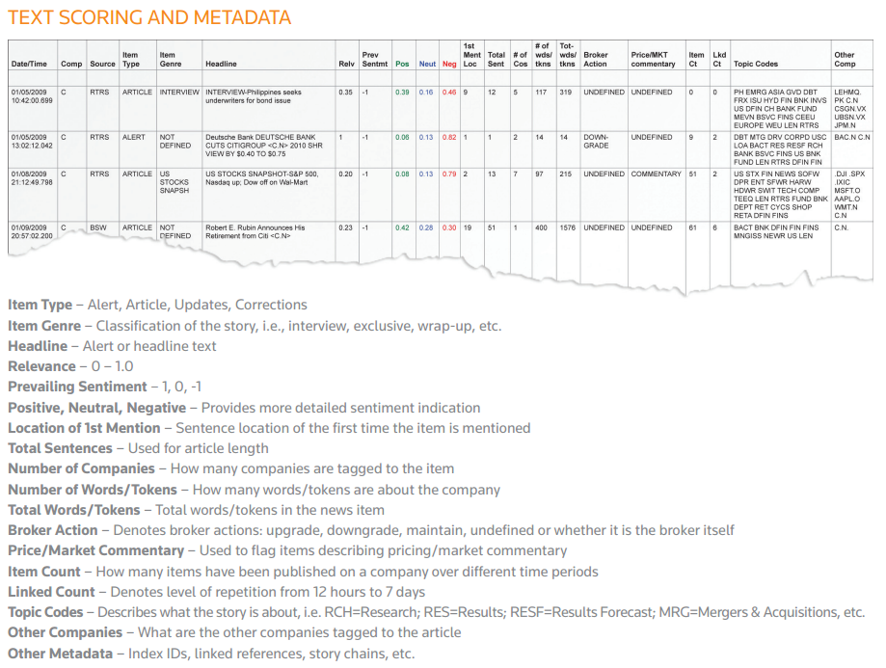

**Source from:**

http://thomsonreuters.com/content/financial/pdf/enterprise/News_Analytics.pdf

**Diagram 2: Full-Time News Journalists**

**Source from:**

[**http://thomsonreuters.com/products_services/financial/content_news/news_overview/**](http://thomsonreuters.com/products_services/financial/content_news/news_overview/)

[**http://www.pgatour.com/tournaments/r505/sponsors.html**](http://www.pgatour.com/tournaments/r505/sponsors.html)

[**http://www.casbaa.com/privacy-policy/1362-bloomberg-television**](http://www.casbaa.com/privacy-policy/1362-bloomberg-television)

**Diagram 3: Market Share / per Journalist**

**Diagram 4: Market Data & Analysis Industry**

**Source from:**

[**http://news.efinancialcareers.com/121456/sectors-explained-data-providers-ratings-agencies/**](http://news.efinancialcareers.com/121456/sectors-explained-data-providers-ratings-agencies/)

**Diagram 4: Unique Visitors per month**

**Source from:**

[**http://www.bloomberg.com/pressroom/facts/**](http://www.bloomberg.com/pressroom/facts/)

[**http://online.wsj.com/article/PR-CO-20121113-913441.html?mod=crnews**](http://online.wsj.com/article/PR-CO-20121113-913441.html?mod=crnews)

[**http://www.mediabuyerplanner.com/cat/social-media/**](http://www.mediabuyerplanner.com/cat/social-media/)

**Diagram 5: Average Scoring from online reputable Review websites**

**Source from:**

[**http://www.top20sites.com/Top-Financial-News-Sites**](http://www.top20sites.com/Top-Financial-News-Sites)

[**http://www.investimonials.com/websites/reviews-reuters-com.aspx?page=1#reviews**](http://www.investimonials.com/websites/reviews-reuters-com.aspx?page=1#reviews)

**Diagram 6: Sample of Reuters’s News article**

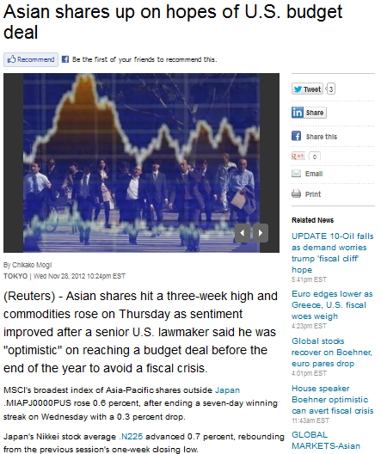

**Source from:**

[**http://www.reuters.com/article/2012/11/29/us-markets-global-idUSBRE88901C20121129**](http://www.reuters.com/article/2012/11/29/us-markets-global-idUSBRE88901C20121129)

**Diagram 7: Sample of Wall Street Journal’s News article**



**Source from:**

[**http://blogs.wsj.com/marketbeat/2012/11/28/wild-wednesday-for-stocks-may-signal-swoons-end/?KEYWORDS=stocks**](http://blogs.wsj.com/marketbeat/2012/11/28/wild-wednesday-for-stocks-may-signal-swoons-end/?KEYWORDS=stocks)

**Diagram 8: Sample of Bloomberg’s News article**



**Source from:**

http://www.bloomberg.com/news/2012-11-29/asian-stocks-rise-on-u-s-budget-remarks-japan-stimulus.html

**References**

10 Financial Websites That Help You Stay On Top Of The Market. (2011). Retrieved Nov 24, 2012, from <http://www.makeuseof.com/tag/10-financial-websites-stay-top-market/>

Data Feeds. (2012). Retrieved Nov 24, 2012, from <http://www.bloomberg.com/enterprise/enterprise_products/data_optimization/data_feeds/>

# Dow Jones Introduces News Analytics to Institutional Trading Community. (2012) . Retrieved Nov 24, 2012, from <http://www.prnewswire.com/news-releases/dow-jones-introduces-news-analytics-to-> institutional-trading-community-139277198.html

Financial News Sites. (2009). Retrieved Nov 24, 2012, from http://financial-news.choice-review.com/

Press Release. (2012). Retrieved Nov 24, 2012, [http://www.dowjones.com/pressroom/releases/2012/ 06192012-DowJones-0044.asp](http://www.dowjones.com/pressroom/releases/2012/%20%0906192012-DowJones-0044.asp)

Thomson Reuters News Analytics. (2010). Retrieved Nov 24, 2012, from <http://thomsonreuters.com/content/financial/pdf/enterprise/News_Analytics.pdf>

Thomson Reuters News Analytics For Internet News and Social Media. (2012). Retrieved Nov 24, 2012, from <http://thomsonreuters.com/content/financial/pdf/enterprise/news_analytics_and_social_> media.pdf

Top 7 News Sources for Financial Trader. (n.d). Retrieved Nov 24, 2012, from

<http://www.topforexnews.com/top-7-news-sources-for-financial-trader/>